2019-2020学年第一学期期末模拟试卷
初一年级英语
注意事项：
1.本试卷共7大题,满分100分,考试用时100分钟,
2.答题前,考生务必将自己的姓名、考点名称、考场号、座位号、考试号填写清楚,并用2B铅笔认真正确填涂考试号下方的数字；
3.答选择题必须用2B铅笔把答题卡上对应题目的答案标号涂黑.如需改动,请用橡皮擦干净后再选涂其他答案；答非选择题必须用0.5毫米黑色墨水签字笔写在答题卡指定的位置上,不在答题区域内的答案一律无效,不得用其他笔答题；
4.考生答题必须答在答题卡上,答在试卷和草稿纸上一律无效。
第I卷（共四大题；共59分）
- 听力选择(共15小题; 每小题1分,满分15分)
A) 听下面3段对话。每段对话后有三幅图,从A、B、C三幅图中选出与你所听内容相符的选项。每段对话读两遍。
1. Which girl is Linda?
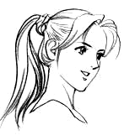
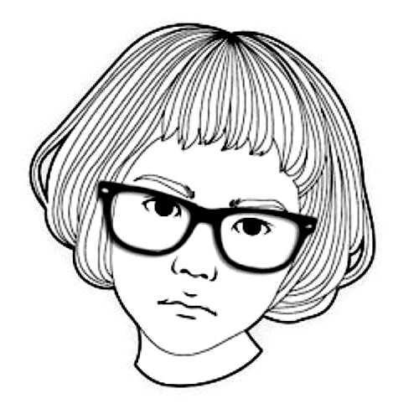
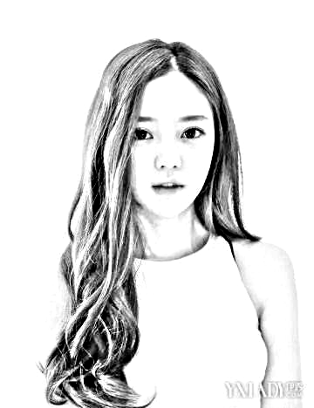
A. B. C.

2. What is the girl looking for?
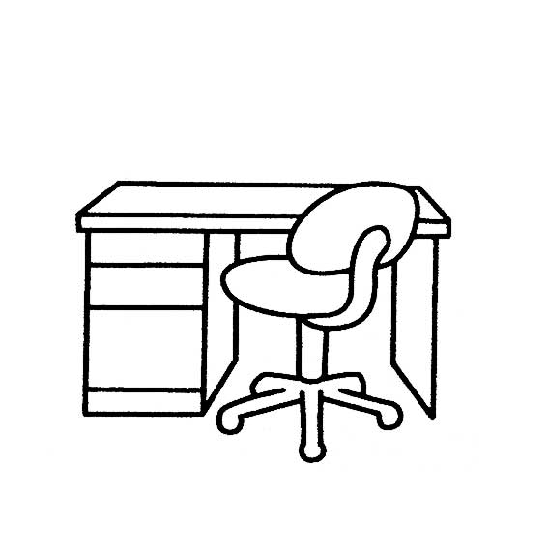
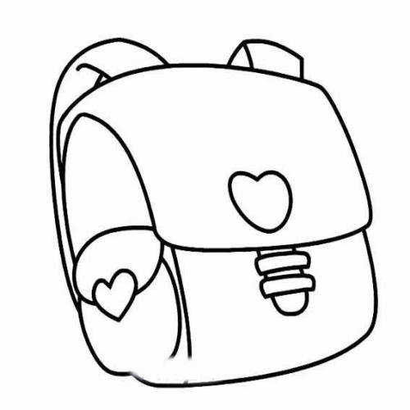
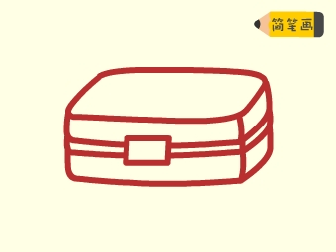
A. B. C.

3. What do Helen’s parents like best at the weekend?
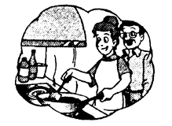
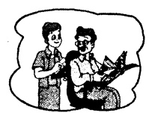
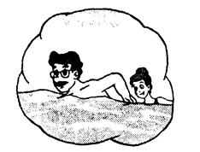
A. B. C.

B) 听下面3段对话。每段对话后有一个小题,从题中所给的A、B、C三个选项中选出最佳选项。每段对话读两遍。
4. What is Andy going to buy for Simon?
A. A football. B. Some football cards. C. A birthday card.
5. Where is Simon’s classroom?
A. On the ground floor. B. On the second floor. C. On the third floor.
6. Who buys the toy panda for the boy?
A. His mother. B. His aunt. C. His uncle.
C) 听下面3段材料。每段材料后有几个小题,从题中所给的A、B、C三个选项中选出最佳选项。每段材料读两遍。
听第一段材料, 回答第7至第8题。
7. What day is it today?
A. Saturday. B. Sunday. C. Friday.
8. What does the boy want to buy?
A. A pair of sports shoes. B. A T-shirt. C. A pair of shorts.
听第二段材料,回答第9至第11题。
请根据内容从A、B、C三个选项中选出最佳选项,完成信息记录表。
Mary’s Summer Holiday
In the morning | ·Talking with her parents.  ·Doing homework for 9 .
In the afternoon | ·Going to the 10 lessons.
In the evening | ·Walking her dog.  · 11 at 8:30.  Play computer games too long.
9. A. 1 hour B. 2 hours C. 3 hours
10. A. drawing B. dancing C. piano
11. A. Watching TV B. Playing computer games C. Listening to music
听第三段材料,回答第12至第15题。
12. Where are Kitty’s parents now?
A. In America. B. In China. C. In Japan.
13. What’s the weather like today?
A. It’s sunny. B. It’s rainy. C. It’s cloudy.
14. What’s she going to see?
A. A car show. B. A fashion show. C. A flower show.
15. Does she find the way at last?
A. Yes, she does. B. No, she doesn’t. C. I don’t know.
二、单项填空（共10小题；每小题1分,满分10分）
( )16. There is ________“m” and________ “u” in the word “much”.
A. a; a B. an; an C. a; an D. an; a
( )17. -I don’t know _______ for the party.
-You look so good now.
A. what to wear B. how to wear it C. what to wear it D. how to wear
( )18. -How much money does it Tom?
-About 20 yuan. He thinks it’s very cheap.
A. take B. spend C. cost D. pay
( )19. There are thirty ________ and eight hundred ________ in our school.
A. woman teachers; girl student B. women teachers; girls students
C. women teachers; girl students D. woman teachers; girl students
( )20. -I sometimes don't have enough time _______ with my parents.
-You should spend more time _______ with them at home.
A. to chat; to stay B. to chat; staying
C. chatting; to stay D. chatting; staying
( )21. - ________do you go to that cinema?
-Seldom. I have too much work to do every day.
A. How long B. How often C. How many times D. How soon
( )22. - _____ is your uncle?
-He is a teacher. He teaches history in a middle school.
A. How B. Which C. What D. Who
( )23. -It is really difficult to fly this big kite.
-Have ________ try. Don’t say “No” before you try your best.
A. other B. the other C. others D. another
( )24. -Where are you going?
-To the cinema. Sue for me outside.
A. waits B. is waiting C. waited D. will wait
( )25. -I will go to Hainan for a holiday.
-________
A. Good idea! B. Can I go with you? C. Pardon? D. Have a good time!
三、完形填空 （共1小题；每小题10分,满分10分）
Mr. Davis comes to his son’s bed and sits down beside him. Looking at that little sad face, he asks,"Eric,what kind of 36 do you have?”
“It is a 37 day for me, Daddy. " Tom answered. "I have a fight(打架)with David. We make our teacher angry. She sends a note home about me. And I talk back to Mum. She is 38 , too. I am so sorry, Daddy. "
"Now, I know part of the day is bad," says Mr. Davis. “ 39 tell me about the best thing today. ”
Jack thinks for a minute and 40 . "After school I go fishing myself, " he says. "I don't think I could have any 41 . But I do. I catch a big fish! "
"I'm glad you have a good time," said Mr. Green. "Try to think about it before you go to sleep. Now I'm going to 42 the light. I hope I will see a happy boy tomorrow. Good night! " Every night, Tom answers the 43 question. "What is the best thing to you today?" Every night, Tom thinks about it. Of course it is very helpful for him to have a good sleep.
Sometimes he has to think 44 to find the best thing. Sometimes it is a very small thing. But he always finds one good thing to think about. This is a good way Eric’s father teaches him to 45 his day.
26. A. activity B. lesson C. date D. day
27. A. bad B. good C. interesting D. happy
28. A. angry B. happy C. beautiful D. careful
29. A. and B. or C. but D. if
30. A. cries B. sleeps C. shouts D. smiles
31 .A. lesson B. dream C. luck D. help
32. A. turn on B. turn off C. open D. close
33. A. same B. different C. easy D. difficult
34. A. fast B. sadly C. next D. hard
35. A. begin B. end C. stop D. play
四、 阅读理解（共4小题；每小题6分,满分24分）
A
EXPO open every day 10:00--23:00
Milano 2019 From May 1 to October 31, 2019
●SEASON PASS
If you want to enjoy Expo Milano 2019 throughout the whole six months, his is your choice(选择).
●FAMILY PACKAGE
Expo Milano 2019 offers special packages for families with children. You can make a best plan for your visit and click(点击) on BUY NOW to make your Family Package.
●EVENING TICKET
If you love an evening of fun and delicious food, then this specially- priced ticket is for you. An unforgettable journey waits for you, starting at 7 p.m.
●SPECIAL DISCOUNT
Are you over 65? Do you have a child of 13 years or less? Are you a student under 26 years? Are you’re a person with disability(残疾)? Then you can get the tickets at a lower price.
36. Expo Milano 2019 lasts ______ and is open for ______ every day.
A. half a year; 13 hours B. 5 months; 13 hours
C. six months; 10 hour D. 5 months; 23 hours
37. ______ kinds of tickets are introduced here for Expo Milano.
A. Three B. Four C. Five D. Six
38. SPECIAL DISCOUNT isn’t suitable for ______.
A. the disabled B. children aged 13 or less
C. students over 26 years D. old people aged over 65
B
Do you have any friends from other countries? Do you know what they are like?
The Germans are very quiet and they don't get excited easily. They don't want to say more words. They leak serious(严肃的)，but they really know how to have fun. They work hard and like tidiness, Most German women like to keep their houses clean.
In same ways, the English look the same as the Germans. They are also quiet and never talk too much with others. They are really polite, so we often hear "Thank you." or "Sorry." From them.
The French have long holidays. They like travelling and usually spend their long time in other countries. The French are more outgoing(外向的)than the Germans. It is very easy to make friends with them.
Compared to(与……比较)the French, the Americans are more outgoing. And they are even opener They don't like to depend on(依靠)others. So it is very popular that students do part-time jobs. In Americans' eyes, working and success are important.
39. From the passage, we can learn that _______ are very quiet.
A. only the Germans B. only the English
C. only the French D. both the Germans and the English
40. The underlined word "tidiness" in paragraph 2 means ________ in Chinese.
A.整洁 B.安静 C.时尚 D.随意
41. What can we learn about the French from the passage?
A. They are more outgoing than the Americans.
B. It is very easy to make friends with them.
C. They like travelling in their own country.
D. They don't like to be too excited and are always hard-working.
C
From small shops to large shopping malls, from common(普通的)shops to popular supermarkets, China has a lot of wonderful places to shop. Most large Chinese cities, like Beijing, Xi'an, Hangzhou and Guangzhou, have special business streets. You can buy good and cheap things there.
Wangfujing Street in Beijing is one of the largest and most popular shopping streets in China. There are many outdoor cafes(咖啡馆)in summer-a nice place to take an ice cream or cold beer under a large umbrella in the street. There are also many large department stores(百货商店),souvenir stores(纪念品商店),food stalls(小吃摊)and Chinese painting stores. In the evening, there is an evening food market selling all kinds of Beijing local(当地的)snacks.
Chengdu’s shopping centres are all at Chunxi Road, the biggest and busiest shopping area in town. Shopping malls, supermarkets, cafes and restaurants make it a fun area to visit.
There are also other famous shopping streets in China, such as Shangxiajiu Pedestrian Street in Guangzhou, Bankhor Street in Tibet and Central Avenue in Harbin. If you come to China, I am sure you will have a good time in these places.
42. You may read this article from .
A. a sports newspaper B. a storybook C. a magazine D. a shopping list
43. How many shopping streets are mentioned(提及)in this article?
A. 2. B. 3. C. 4. D. 5.
44. What does the article mainly(主要)tell us?
A. How to shop in China. B. Famous shopping streets in China.
C. Travelling in China. D. Different food markets in China.
D
As students, you may have many dreams. They can be very big like becoming Superman, or they can be small. You may just want to become one of the ten best students in your class.
If you find a dream, what do you do with it? Do you ever try to make your dream come true? Follow Your Heart by Australian writer Andrew Matthews tells us that making our dreams come true is life’s biggest challenge.
“You may think you’re not very good at some school subjects, or that it is impossible (不可能) for you to become a star. These ideas stop you from realizing your dream,” the book says.
In fact, everyone can make his dream come true. The first important thing you must do is to remember what your dream is.
Don’t let it leave your heart. Keep telling yourself what you want. Do this step by step (一步一步地) and your dream will come true faster. A big dream is, in fact, many small dreams.
Never give up (放弃) your dream. There will be difficulties on the road. But the biggest problem comes from yourself. You need to decide what is the most important. Studying instead of (代替) watching TV will bring you better exam points. Saving five yuan instead of buying an ice cream means you can buy a new book. When you get closer to your dream, it may change a little. Then you will be able to learn more skills and find new interests.
45. Follow Your Heart is _______.
A. the first thing you must do to make your dream come true
B. the most important dream to have for students
C. the name of a book by Andrew Matthews
D. the name of a famous Australian writer
46. If you want to make your dream come true, you should _______.
A. remember what your dream is first B. keep telling yourself what you want
C. never be afraid of the big difficulties D. try to start with all the things above
47. What is the best title (标题) of the text?
A. Keep Your Dream in Your Heart. B. How to Find Your Dream.
C. Make Your Dream Come True. D. Students Have Many Dreams.
第II卷（共五大题；共41分）
五、 词汇检测（共10小题；每小题1分,满分10分）
48. -Do you know January 26th is a ____________（特别的）day to the students this year?
-Yes. The winter holiday begins on that day.
49. Thank you for __________ (涂) the walls of our classroom white.
50. My dream is to be a doctor and save _________ (生命).
51. She plans to ________(改变) his lifestyle now.
52. Lily usually sleeps __________(少) than 6 hours every night.
53. -What is your dream home?
-I would like to live in a white house ___________ (在…中) the trees．
54. -My pen is _________from your pen.
-Yes. One is pink and the other is red. They are not the same.
55. -I think the blouse ________ your trainers very well.
-OK, I’ll take it.
56. Thanks, ladies and _________, for coming to our school.
57. I think pigs are ________. They sleep and eat every day.
六、句型转换（共5小题；每小题1分,满分5分）
58. I want to buy some hair clips for Millie.（同义句转换）
I want to _______ ________some hair clips.
59. Can I borrow your bike this afternoon, Jim? （同义句转换）
Can you ______ your bike ______me this afternoon, Jim?
60. The girl over there is Lily’s sister. (对划线部分提问)
is Lily’s sister?
61. Amy looks great in her new sports clothes.（同义句转换）
Amy’s new sports clothes _________ great _________ ________.
62. My father watches TV for two hours every day. (对划线部分提问)
_______ ______ _______ your father ________ TV every day?
句子翻译（共5小题；每小题2分,满分10分）
63.吃太多肉对你的健康没有好处。
64.Kitty每周三下午放学后练习打排球。
65.他对收集邮票感兴趣吗?
66.这件衬衫是由丝绸制成的而且非常舒服。
67. Dandy将带那些英雄参观这个现代化的图书馆。
八、 阅读表达（共1题；满分6分）
One day, Lucy’s grandma broke her leg. So she had to sit in a chair all day.
“Soon you will be able to walk around with a cane,” the doctor told her. “But for now, I want you to keep the weight off your legs.”
Everyone in the family wanted to help Grandma. They thought and thought.
Suddenly, Lucy had an idea. She told her mother about her plan. Together, they went to the store and bought what they needed. Then they drove to Grandma’s house.
“We came to have a dumpling party with you!” Lucy told her grandma, “I know that dumplings are your favourite food. Today we are going to make many different kinds of dumplings.”
Lucy and her mom worked hard for an hour and made lots of dumplings.
Then, they boiled some water and cooked dumplings. Soon, everyone was enjoying a big bowl of steaming hot dumplings.
Best of all, Lucy’s grandma wasn’t sad any more. She was smiling.
- What was wrong with Lucy’s grandma?
- How did Grandma feel when Lucy and her mom held the dumpling party for her?
- What do you think of Lucy? Why?
九、书面表达（共1题；满分10分）
寒假将至,同学们即将迎来一个快乐的寒假。你的同学Sandy通常是这样度过寒假的,
请你介绍一下Sandy的寒假生活。
健康生活 | 1.早睡早起;多吃水果和蔬菜,多做运动;  2.常穿运动服。  3…
快乐学习 | 1.做2小时作业;  2.空余时间读书看报。  3…
庆祝活动 | 1.和家人团聚吃大餐;  2.与同学聚会开派对。  3…
注意:1.词数80左右。短文的开头已为你写好,不计入总词数;
2.短文须包括所有要点,不要逐词翻译,可适当发挥,使短文连贯、通顺;
3.短文中不得提及真实的人名、校名等相关信息。
Sandy's Winter Holiday
Hello, I'm happy to tell you something about Sandy's winter holiday.

