2017～2018学年度第一学期阶段性质量调研
九年级英语试题
2017.11
（考试范围: 至牛津初中英语9上 Unit4）

注意事项：1．本试卷共10页，满分100分。考试时间100分钟。
2．请将答案全部填写在第8—10页的答题纸上，在1-7页上答题无效．
第一卷（共71分）
一、听力（共20小题；每小题1分，满分20分）
A) 听下面10段对话。每段对话后有1个小题，从题中所给的A、B、C三个选项中选出最佳选项。听完每段对话后，你都有10秒钟的时间来回答有关小题和阅读下一小题。每段对话读两遍。
1. What is Sandy’s animal sign?
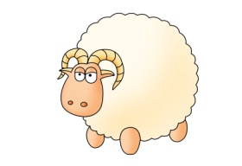
2. What will the weather be like tomorrow?

3. How can the boy relax himself according to the girl?

4. What is the woman going to do this weekend?
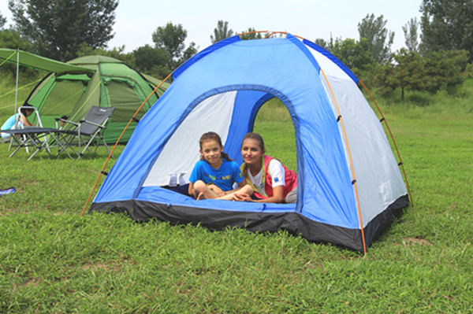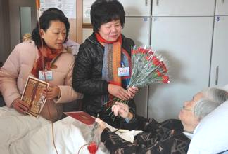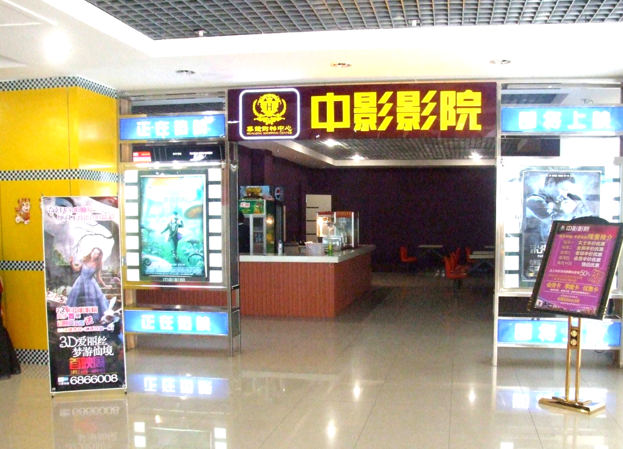
5. What time will they probably get to the museum?
A. At 8:35. B. At 8:40. C. At 8:45.
6. What color may the man like?
A. Yellow. B. Blue. C. Red.
7. Why does Millie have so many friends?
A. Because she never makes any mistakes.
B. Because she takes good care of herself.
C. Because she always cares about others.
8. What’s Miss Green like?
A. Creative. B. Active. C. Organized.
9. What does the woman advise the man to do tonight?
A. Stay up late. B. Go to bed early. C. Stay awake.
10. What are they talking about?
A. A film. B. A 12-year-old boy. C. A book.
B) 听对话或独白。每段对话或独白后有几个小题，从题中所给的A、B、C三个选项中选出最佳选项。听每段对话或独白前，你将有时间阅读相关小题，每小题5秒钟。听完后，每小题你仍有5秒钟的时间来选择你认为最合适的答案。每段对话或独白读两遍。
听第一段对话，回答第11—12小题。
11. What strong qualities does Judy have?
A. She is hard-working and organized.
B. She is patient and hard-working.
C. She is clever and organized.
12. Who will the boy choose most probably to be the chairperson of the Students’ Union?
A. Judy. B. David. C. Either of them.
听第二段独白，回答第13—15小题。
Sandy’s dream
Sandy’s dream job | She wants to work in an international 13 .
The problem she has | She does not like to 14 .
Her future plan | She has decided to 15 .
13. A. company B. school C. hotel
14. A. live away from home B. eat foreign food C. learn foreign languages
15. A. go back to college B. find another job C. study harder
听第三段独白，回答第16—20小题。
16. Where does Franco work?
A. In a factory. B. In a hospital. C. In an office.
17. How long is his summer holiday every year?
A. 30 days. B. 15 days. C. 7 days.
18. How did he go to San Francisco?
A. By plane. B. By sea. C. By train.
19. What did he see when he arrived at San Francisco?
A. A poster. B. A letter. C. A friend.
20. What did he do in San Francisco?
A. He traveled in the countryside.
B. He helped the injured (受伤的) people.
C. He talked to the people there.
二、单项填空 （共10小题；每小题1分，满分10分）
从A、B、C、D四个选项中，选出可以填入空白处的最佳选项。
21. It’s lucky of the monitor to have ________ extra chance after ________ last week’s exam.
A. a; the B. an; the C. a; a D. an; /
22. --- It’s dangerous to walk across the street carelessly.
--- You’re right. We can’t be ________ careful while crossing the street.
A. so B. very C. too D. more
23. --- Did you enjoy the military training these days?
--- Yes! Though I was ________dead after so much hard training.
A. so good as B. as well as C. as good as D. so well as
24. --- What about playing football this afternoon, Sam?
--- I would rather ________ at home than ________ football. It’s too hot outside.
A. stay; play B. stay; playing C. to stay; to play D. to stay; play
25. Mike is always forgetful. Please remember to remind him ________ the important interview
________ he won’t miss it.
A. about; because of B. of; so that C. about; as a result D. of; because
26. --- Excuse me, but how can I get to the nearest library?
--- Walk straight on ________ you see a white house on your right.
A. whenever B. since C. until D. while
27. I wonder when Linda ________. I’ll meet her at the airport when she ________.
A. will return; will return B. returns; will return
C. returned; returned D. will return; returns
28. Neither the manager nor the boss ________ to the engineer who is working on the high-speed railway.
A. knows what has happened B. knows what is happened
C. know that has happened D. know what is happening
29. --- Excuse me, could you tell me ________?
--- Sorry, I have no idea. I’m new here.
A. the railway station is far from here
B. that you celebrate Christmas
C. if there used to be a building with a long history here
D. whether you have been to France
30. --- I heard that your favourite American novelist was F. Scott Fitzgerald.
--- ________. Actually, he is my cousin’s favourite.
A. That’s true. B. That’s not the case.
C. I can’t agree more. D. It’s said so.
三、完形填空（共12小题；每小题1分，满分12分）
As a teenager, I felt I was always letting people down. I was rebellious (叛逆) outside, but I want to be 31 inside.
Once I left home to California with my friend Penelope. The trip wasn’t 32 , and there were many times I didn’t feel safe. One accident made me nearly lose my 33 . I was thankful to still be alive. When I returned home, I was different — not so outwardly sure of myself.
I was happy to be home. But then I 34 that Penelope, who was staying with us, was wearing my clothes. And my 35 seemed to like her better than me. I wondered if I would be missed if I weren’t there. I told my mom, and she explained that 36 Penelope was a lovely girl, no one could replace (取代) me. I pointed out, “She is more patient and is neater than I have ever been.” My mom said these were wonderful 37 , but I was the only person who could fill my role. She made me realize that I was not 38 , even sometimes made mistakes, but I was a loved member of the family who couldn’t be replaced.
I became a searcher wanting to 39 who I was and what made me unique (特殊的). My view of 40 was changing. I wanted a strong base to start from. I started to fight against pressure to act in ways that I didn’t like any more, and I was happy after I figured out who I 41 was. I came to feel much more sure that 42 can ever take my place.
Each of us holds a unique place in the world. You are special, no matter what others say or what you may think. So forget about being replaced. You can’t be.
31. A. hated B. liked C. learned D. taught
32. A. easy B. difficult C. surprising D. terrible
33. A. money B. friend C. life D. family
34. A. noticed B. appeared C. expressed D. heard
35. A. classmates B. friends C. teachers D. family
36. A. because B. even C. although D. since
37. A. words B. qualities C. facts D. reasons
38. A. careful B. helpful C. silly D. perfect
39. A. find B. find out C. look for D. trust
40. A. myself B. others C. friendship D. life
41. A. generally B. simply C. hardly D. really
42. A. someone B. anyone C. everyone D. no one
四、阅读理解（共12小题；每小题2分, 满分24分）
阅读下面短文，从各题所给的A、B、C、D四个选项中，选出最佳选项。
（A）
Hengshui is a city in Hebei province. It is well known across China. But that’s not because it has a beautiful landscape. It’s because of a school there called Hengshui High School.
The school has a nickname: the gaokao factory. It does all it can to make its students study hard. There are many strict rules. For example, they set times for students to eat and go to the toilet. Another rule is that students have to get up at 5:30 am and go for a run. There are many discussions about the rules.
This month, the school opened a new school in Pinghu, Zhejiang. This started another hot discussion.
Some people say the school only cares about the exam scores. It is not good for the all-round development of students, wrote The Beijing News.
However, some think that although not everyone agrees with the school’s rules, it gives students a way to get into the best universities.
Last year, 139 of its students went to Peking University and Qinghua University, reported China Youth Daily. The number is the highest among all Chinese high schools.
43. Why is Hengshui so famous in China, according to the story?
A. Because it is a city in Hebei province. B. Because it has a beautiful landscape.
C. Because it has a special high school. D. Because it has a special factory.
44. Which is NOT the school’s rules?
A. Students should have meals in a given time.
B. Students should go to the toilet at a certain time.
C. Students should study for 12 hours every day.
D. Students should get up early to go for a run.
45. What happened to Hengshui High School this month?
A. The school started a new school in Pinghu, Zhejiang.
B. The school will move to Pinghu, Zhejiang.
C. The school will stop their way of education.
D. Universities in China took 139 of its students.
46. What makes some people agree with the school’s rules?
A. The school cares enough about the exam scores.
B. Students from this school get all-round development.
C. It gives students a chance to get into the best universities.
D. It gives the universities a lot of good students.
（B）
A woman whose sports car was stolen with her dog in it put up notices all over the area. It was clear that getting back her pet was more important than her car.
“Whoever did this can keep my car. Please let Tom come home,” the notice said.
It is not known whether the thief showed any pity, but almost 30 hours after the 1 p.m. theft Friday, Julie and Tom, a 10-year-old black retriever (猎犬), were reunited (重聚). “He’s hungry. He’s dirty, but he’s very happy to be home,” Julie said.
The car was found in an area full of off-the-road cars and dirt bikes. However, the police couldn’t control Tom, and they had to call Julie to come and get him.
Julie said the thief cared for Tom a little by providing him with some dry dog food. She believed Tom ended up drinking some muddy water in the area.
She said they have been together for nearly 8 years after she took him back from a society shelter in Dallas, Texas.
Before Tom was found, Julie and several friends put up notices all over the city. They also contacted animal shelters, throughout southern New Hampshire and Massachusetts. The notice stated there was a reward (报酬), and also that the dog needed medical treatment. Any caller could remain anonymous. Julie had parked the car outside a hardware store with the keys inside and gone in to buy a carpet cleaner.
“It was 10 minutes and I came out and my car was gone along with Tom in broad daylight,” Julie said. The car thief threw her wallet and other items out of the car before getting away from the scene.
47. Which of the following shows the correct order of what happened?
a. Notices were put up saying there was a reward.
b. Julie saw Tom again.
c. Police found Julie's car.
d. Julie took Tom back from a society shelter.
e. Julie bought a carpet cleaner in a hardware store.
A. d, e, a, b, c B. d, e, a, c, b C. e, a, d, b, c D. e, a, c, d, b
48. What does the underlined word “anonymous” mean in Chinese?
A. 秘密的 B. 沉默的 C. 匿名的 D. 神秘的
49. Which of the following is TRUE according to the passage?
A. The dog was sent back immediately after Julie put up the notices.
B. Julie and her friends worked very hard to look for her dog.
C. The thief gave the dog back but kept the sports car.
D. All the things in the car were taken away by the thief.
50. What would be the best title for the passage?
A. A car with a dog was stolen
B. Lucky dog was returned to his owner
C. Stealing cars: a most important social problem
D. Woman wants dog back more than stolen car
（C）
Rats are not many people’s favourite animals. But in most places, people have to learn to live with them.
Not in New Zealand, though. To save native (本国的) birds, the country plans to get rid of rats, possums (负鼠) and stoats (白鼬) by 2050, reported Time for Kids.
In New Zealand, rats are an invasive (入侵的) species. They arrive on boats, along with the island’s first human settlers, in the 13th century. Scientists believe that as time passed by, the rats ate and killed off several bird species on the island.
Humans also brought other animals like stoats and possums. In the beginning, stoats were hoped to eat another kind of invasive animal: rabbits. However, the stoats fed on native species instead.
Likewise, possums were introduced because people wanted their fur. But their population quickly grew out of control. Possums feed on the eggs and young of native birds.
Most of New Zealand’s native species are birds. Many, like the national bird, the kiwi (几维鸟), can’t fly. Because they spent so long without a natural enemy, the birds lost the need to fly. When mammals (哺乳动物) like rats arrived, being not able to fly became a big problem for the birds.
The government of New Zealand suggests several ways to get rid of the mammals. Traps (捕鼠夹) and bait (诱饵) stations are the main types.
Genetic methods are also used. For example, scientists are trying to use gene technology to cause sterility (不育) in rats to control their population, reported Nature Research online.
51. All of the following animals are invasive species EXCEPT ________.
A. rats B. rabbits C. stoats D. kiwis
52. The possums were introduced to ________.
A. kill another invasive species B. provide fur for people
C. kill the bird on the island D. provide food for other mammals
53. Kiwis lost their ability to fly because ________.
A. they are too heavy to fly B. they don’t have wings
C. they don’t have a natural enemy D. they live under the ground
54. From the last two paragraphs, we can infer(推断) that ________.
A. the government has no idea how to deal with the mammals
B. another new species will be introduced to kill the mammals
C. gene-changing technology has proven to be a big success
D. traps and bait stations work better than other ways
五、任务型阅读（共5小题；每小题1分, 满分5分）
阅读下面短文，在表格内的空白处填入合适的答案(每格限填一词)。
Making the most of time is important in our life. Here are some tips that might be of help to you.
- Make a plan. You should make a plan every week. The plan includes things you want to finish. You should know what the most important ones are, and try your best to do them first.
- Control your stress. No matter what kind of stress you have, try to keep cool. When you have a lot of things to do, too much stress may make you slow. Don’t work all day without breaks.
- Close your door. When working under a plan, do your important things with your door closed. This will give you a better-quality time.
- Focus on one thing at a time. Don’t try to do many things at a time! You will lose your focus, and it will take you longer to finish your work.
- Just say “no”. If you really don’t have the time to help out, just say “no”. You’re only one person, and you can’t save the world by yourself!
- Stop wasting time on the phone. While talking on the phone, keep your conversations short. In this way, you’ll waste much less time.
- Relax. The most important thing is to take time to relax. Even if it’s a 10-minute walk, get away from your work and get relaxed.
55 Tips to Make the Most of Time
Make a plan. | Make a list of what you want to finish every week.  Devote yourself to the most important things first.
Control your stress. | Take breaks instead of 56 all day long.
Close your door. | Make sure that your door is 57 while doing your important things.
Focus on one thing at a time. | If you try to do many things at a time, you will need to 58 more time finishing your work.
Just say “no”. | Learn to refuse others if you are really busy.
Stop wasting time on the phone. | Much time will be wasted 59 you keep your conversations short while talking on the phone.
Relax. | Getting away from what you are doing for a short while is the most important thing.
2017～2018学年度第一学期阶段性质量调研
九年级英语答题纸
201711
第一卷 (共71分)
一、听力（共20小题。每小题1分，满分20分）
题 号 | 1 | 2 | 3 | 4 | 5 | 6 | 7 | 8 | 9 | 10
答 案
题 号 | 11 | 12 | 13 | 14 | 15 | 16 | 17 | 18 | 19 | 20
答 案
二、单项填空（共10小题。每小题1分，满分10分）
题 号 | 21 | 22 | 23 | 24 | 25 | 26 | 27 | 28 | 29 | 30
答 案
三、完型填空（共12小题。每小题1分，满分12分）
题 号 | 31 | 32 | 33 | 34 | 35 | 36 | 37 | 38 | 39 | 40 | 41 | 42
答 案
四、阅读理解（共12小题。每小题2分，满分24分）
题 号 | 43 | 44 | 45 | 46 | 47 | 48 | 49 | 50 | 51 | 52 | 53 | 54
答 案
五、任务型阅读（共5小题。每小题1分，满分5分）
55．________________ 56．________________ 57．________________
58．________________ 59．________________
第二卷（共29分）
六、词汇运用（共8小题；每小题1分, 满分8分）
（A）根据句意，用所给单词的适当形式填空。
60. He is so bad at making _______________ (decide) that it has already taken him two weeks.
61. Many pop stars dislike being asked _______________ (person) questions in public.
62. In the end, the engineer broke the ________________ (silent) and began to talk.
63. There was a lot of traffic everywhere because of the 8-day holiday we had on _______________ (nation) Day.
（B）根据句意及所给汉语提示完成单词拼写。
64. Very few people can ________________ (发音) the boy’s name correctly.
65. Our basketball team will play ________________ (对抗) the league champions.
66. The government has made great ________________ (进展) in controlling the air pollution.
67. I’ve heard that Hong Kong is one of the ________________ (生气勃勃的) cities in the world.
七、请用所给动词的适当形式填空（共5小题；每小题1分, 满分5分）
68. It is worth _______________ (go) over what you’ve learnt recently before the exam.
69. Mr. James _______________ (prefer) to stay out after work, but things changed because of his little girl’s sudden birth.
70. Anyone _______________ (drive) mad sooner or later if no action is taken.
- --- ___________ the coach ____________ (mention) anything to you about the trip to Germany?
--- Not yet.
- The poor girl had no choice but _______________ (make) a living through hard work.
八、句子翻译（共6小题；每小题1分, 满分6分）
73. David对自己足够严格，才能在班里领先。
David ______________________________________________________________ in his class.
74. 那位外科大夫一得知这个消息就会改变主意。
The surgeon ____________________________________________________________the news.
75. 令我们吃惊的是，这位领导者处理信任问题并没费什么劲。
__________________, ____________________________________________ the trust problem.
76. 史密斯一家上周一直在参加那部新电影的试演吗？
________ the Smiths ___________________________________________________last week?
77. 不仅西蒙的老师还有他的家长已经成功地注意到了他的问题。
________Simon's teacher _______ his parents ___________________________ of his problem.
78. 根据新闻报导所说，不久这个镇将由地铁与市中心相连。
The town ________________________________________________________ the news report.
九、书面表达（满分10分）
假设你校九年级将举办一场主题为“如何解决青少年成长中存在的问题”的英语演讲比赛。请你写一篇100词左右的英语演讲稿。根据表格提示列举青少年中普遍存在的问题，并提出你的观点和解决办法。
问题 | 建议
1.学习和爱好无法平衡 | ……
2. 痴迷网络游戏 | ……
3. | ……
注意：1. 表达中必须包含所给要点，可以适当发挥，不要简单翻译；
2. 表达中不得提及真实校名、班级和姓名。
3. 开头已给，不计入总词数。
Dear classmates,
It’s a fact that we middle school students have some problems. The most important thing is to deal with them properly.
(10词)
(20词)
(30词)
(40词)
(50词)
(60词)
(70词)
(80词)
(90词)
(100词)
(110词)
(120词)

