绝密★启用前 试卷类型：A
滨州市二〇一六年初中学生学业水平考试

英语试题

☺温馨提示：
- 本拭卷分第I卷和第II卷两部分，共12页。满分120分。考试用时120分钟。考试 结束后，将试题卷和答题卡一并交回。
- 答卷前，考生务必用0.5毫米黑色签字笔将自己的姓名、准考证号、座号填写在试 题卷和答题卡规定的位置上。
- 第I卷每小题选出答案后，用2B铅笔把答题卡上对应题目的答案标号涂黑；如需 改动，用橡皮擦干净后，再选涂其他答案标号。答案不能答在试题卷上。
- 第Ⅱ卷必须用0.5毫米黑色签字笔作答，答案必须写在答题卡各题目指定区域内相 应的位置，不能写在试题卷上；如需改动，先划掉原来的答案，然后再写上新的答案；不 准使用涂改液、胶带纸、修正带。不按以上要求作答的答案无效。

第I卷（选择题共80分）
一、听力选择（共20小题，计20分。每小题约有8秒钟的答题时间，）
(一）录音中有五个句子，听句子两遍后，从每小题A、B、C三个选项中选出能对每 个句子做出适当反应的答语。
- A. Yes, we do. B. Yes, we are. C. Yes, we can.
- A. At the school gate. B. Sounds great. C. In the afternoon.
- A. Have a good time. B. Sorry to hear that. C. Congratulations.
- A. In May. B. On Sunday. C. Since last month.
- A. I agree. B. I’m sure. C. I hope not.
(二）录音中有五组对话和五个问题，听对话和问题两遍后，从每小题A、B、C三个选项 中选出能回答所给问题的正确答案。
- what do people do when they meet in the girl’s country?
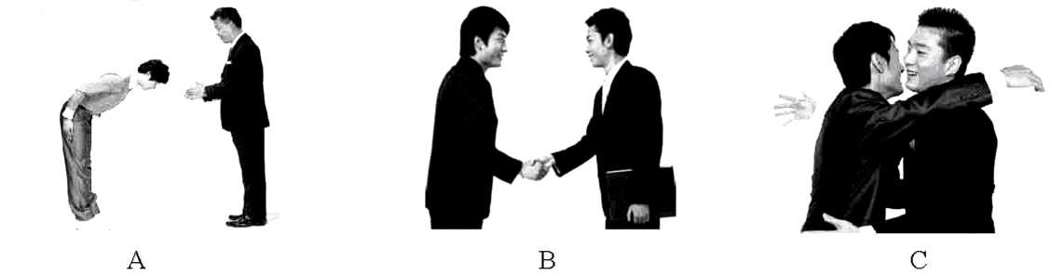
7. Which program does Jenny like best?
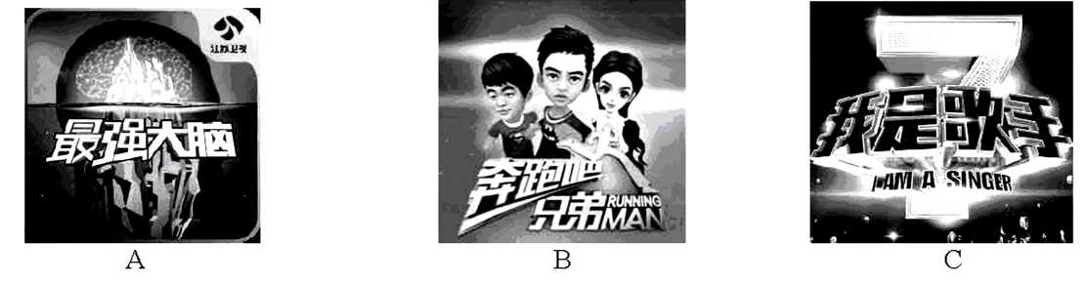
- What would the girl like?
- Some juice. B. Some fruit. C. Some snacks.
- How did the boy like the party?
- Great. B. Boring. C. Noisy.
- Who will help the girl?
- Jack. B. Nobody. C. Mr. Liu.[
(三） 录音中有一段对话和五个问题，听对话和问题两遍后，从每小题A、B、C三个选 项中选出能回答所给问题的正确答案。
- Where may Cathy work?
- At a radio station. B. At a TV station. C. At a middle scho
- What time is it now?
- 6 o’clock. B. 7 o’clock. C. 8 o’clock.
- What’s the problem between David and his mom?
- They don’t care for each other.
- They often argue with each other.
- They have no talk with each other.
- According to the conversation，what can’t David decide by himself?
- What to wear on weekends.
- Which after-school lesson to have.
- When to come back home on weekends.
- What does Cathy advise David to do?
- To ask his father for help.
- To take a trip with his mom.
- To talk about his feelings with his mom.
(四） 录音中有一篇短文和五个问题，听短文和问题两遍后，从每小题A、B、C三个选 项中选出能回答所给问题的正确答案。
- Whom does Li Lei write the letter to?
- His friend. B. His father. C. His classmate.
- Why does Li Lei write the letter?
- He wants to relax himself.
- He wants to ask his father for some pocket money.
- He wants to make his pocket money by himself.
- How do western students get their pocket money?
- By asking parents for it.
- They make it by themselves.
- By working in factories.
- Is it easy for many western students to get their jobs?
A. Yes, it is. B. No, it isn’t. C. We don’t know.
- Where does Li Lei want to get a part-time job?
A_ In his mother’s store.
- In his aunt’s restaurant.
C_ In his father’s supermarket.

二、选择填空（共15小题，计15分）
从A、B、C、D四个选项中，选出可以填入空白处的最佳答案。
- In Chinese, date 5-20 has a similar pronunciation to “I love you”，making it
lucky and romantic day.
- a; the B. /; a C. the; a D. a; /
- —Do you know about the scientist Tu Youyou?
—Yes, she won the 2015 Nobel Prize in medicine because of her great .
- surprise B. achievement
C. education D. satisfactic
- —Don’t be angry with your kid when he makes a mistake again, will you?
—No, I won’t. I know that of us are perfect after all.
- none B. neither C. each D. all
- The “teacher-free exam” means that students take their exams teachers.
Students must be more honest.
A. without B. against
C. through D. by
- —What do you think of the environment here?
—Wonderful! of the land covered with trees and grass.
A. Two fifths; is B. Two fifth; is
- Two fifths; are D. Two fifth; are
- 一“Food Safety” problem is becoming these days.
—I think so. The government must do something to deal with it.
A. smaller and smaller B. worse and worse
C. better and better D. nicer and nicer
- Life is like a mirror. you smile at it, it will smile back.
A. Unless B. When C. Until D. Though
- —Jane won the first prize in the English speech contest.
一 big progress she has made! She used to be weak in English.
A. How B. How a C. What D. What a
- —Can you catch what I said?
—Sorry, I can understand it because you speak very quickly.
A. almost B. probably C. mostly D. hardly
- —I’m sorry I________my exercise book at home this morning.
—It doesn’t matter. Don’t forget it here this afternoon.
A. left; to take B. forgot; bringing
C. left; to bring D. forgot; to bring
31. —Must I go to a law school and be a lawyer like you, Dad?
—No, you . You are free to make your own decision.
A. can’t B. mustn’t C. shouldn’t D. needn’t
- —Which song do you like better, Maria?
—I prefer the song Manual of Youth is sung by TFBOYS.
A. which B. who C. whom D. where
- —We can’t making a plan. Clean-up Day is only two weeks from now.
—Yes, I think so.
A. put on B. put up C. put out D. put off
- —What did your father say to you just now?
—He asked me .
- that I would like to see a movie B. where I will spend my holiday
C. if I enjoyed myself at the party D. when did I attend the graduation party
- — . Where there is a will, there is a way.
—Thanks, Mr. Li. I’ll try my best to improve my English.
- Best wishes B. Never give up C. Have a good trip D. What a pity
三、完形填空（共10小题，计10分）

阅读下面短文，从每题所给的A、B、C、D四个选项中，选出一个能填入文中相应空白 处的最佳答案。
“If you agree with me, please Dianzan.” Do you know Dianzan is one of the most popular words on the Internet? When you think someone’s ideas are right，when you think someone’s articles are 36 , or when you are moved by what someone writes, you can
click (点击）the praise sign. Anyhow，clicking the praise sign 37 that you agree with someone or praise someone.
Dianzan is a kind of Chinese Internet language. People 38
use it when they surf the Liternet. There is a function（功能）of Dianzan in the QQ space. The QQ
space has had the function 39 2010. It didn’t become very popular until Sina blog（新浪博客）
40 the function of Dianzan. In recent years, it has become more and more popular. When the 2015 New Year came, Chinese leader Xi Jinping used the word Dianzan to praise and 41 his thanks to the great Chinese people.
Websites can know how many people support some ideas 42 counting how many people click the praise sign. Experts can know 43 teenagers are caring about through what they click the sign for. That can help them solve teenagers’ 44 .
Clicking the praise sign is really a(n) 45 thing. Have you ever clicked the sign for anybody on the Internet?
- A. wonderful B. terrible C. hard D. awful
- A. offers B. takes C. means D. avoids
- A. never B. luckily C. slowly D. usually
- A. after B. since C. in D. before
- A. broke B. checked C. refused D. started
- A. accept B. express C. create D. receive
- A. by B. on C. at D. under
- A. that B. where C. what D. when
- A. plans B. happiness C. problems D. fairness
- A. difficult B. surprising C. embarrassing D. easy
四、阅读理解（共20小题，计30分）
阅读下面短文，从每题所给的A、B、C、D四个选项中，选出能正确回答所提问题或完 成所给句子的最佳答案。
A
Bury trip -- June 18th, 2016
We will be leaving the Perse School at 13:45. Please be at the school gate 10 minutes early. If you are late, you may miss the bus and not be able to go! If you miss the bus, you won’t get your
money back. The bus is planned to arrive in Bury at 14:30, although this depends on traffic. You will have free time to walk around and we will meet at the same location where we arrived at 17:15 to return to the Perse School by about 18:00.[
Things to do
Visit the Abbey
The Abbey is the min (废墟）of a church which was built more than 1，000 years ago. There are many nice gardens in it. And next to the Abbey, there is a big new church.
Have a drink in the Nutshell
This little bar is famous in Britain because it is officially (正式地）the smallest bar in the country. Good things are put in small bags, and the Nutshell serves some of the area’s finest beer, as well as fascinating photos.
Have a look at a beer shop
At the Greene King shop you can taste and buy some of the local beer, as well as food such as potato chips. There are also clothes available to buy.
Several places are listed, but feel free to plan your own visit.
- If Sara wants to take part in the trip, when should she arrive at the Perse School gate?
- At 13:35. B. At 13:45. C. At 14:20. D. At 14:30.
- What can we see in the Abbey?
- A big museum. B. Tall towers. C. Nice gardens. D. A new church.
- The Nutshell is famous in Britain because of its .
A. small size B. good service C. best beer D. interesting photos
- What can we buy at the Greene King shop?
①beer ②potato chips ③postcards ④books ⑤ clothes
A.①②④ B.①②⑤ C.②③④ D.③④⑤
- The material is probably .
A. a report B. a diary C. an introduction D. a notice
B
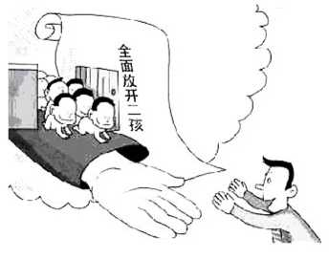
China is a great country with the largest population in the world. In order to solve the population problem, our government carried out one-child policy (政策）before. When it is carried out for some time, many people not only see its advantages but also disadvantages.
From 2016, two-child policy is put into effect. In my opinion, two-child policy is good. First of all, two-child policy is the gift for
some only child. For some families, maybe the parents are only child and they also can have only child. Besides the loneliness of their child, when their child grows up and they grow older, their child marry an only child girl, the burden（负担）on their child and his wife is too heavy. Their child and his wife have to take care of two couples. Usually, a young couple looking after an old couple is a little difficult. But if their parents have two children, they can share the burden of taking care of their parents. It would be much better. Secondly, two-child policy can guarantee (保证) the number of Chinese population.
All in all, one-child policy has been out of date. And two-child policy is needed and necessary. It can solve the problems of nowadays (现在）and the future.
- Which country has the largest population in the world?

A. America. B. Britain. C. China. D. Japan.
- The underlined phrase “carried out” in Paragraph 1 means “ ’’ in Chinese.
A.携带 B.取消 C.禁止 D.实行
- Our government carried out one-child policy before in order to .
- solve the population problem
- take care of two old couples
- share the burden of taking care of their parents
- argue that two-child policy should be put into effect
- According to the passage, which of the following is NOT true?
- One-child policy has its advantages and disadvantages
- It’s easy for a young couple to look after an old couple.
- China is a great country with the largest population in the world.
- For some families, maybe the parents are only child and they also can have only child before 2016.
- What’s the main idea of this passage?
- Two-child policy is needed and necessary.
- Our government carried out one-child policy.
- Two-child policy is the gift for some only child.
- Two-child policy can guarantee the number of Chinese population.
C
“In this life，what did you miss?”
The wife asked the husband when she was 25. Despondently (沮丧地)，the husband replied, “I missed a new job chance.”
When she was 35, the husband angrily told her that he had just missed the bus.
At the age of 45, the husband sadly said, “I missed the chance seeing my close relative before his last breath.”
At 55, the husband said disappointedly, “I missed a good chance to retire (退休).’’
At 65, title husband hurriedly replied，“I missed visiting my dentist.”
At 75, the wife did not ask the husband any more, she was very sick. Remembering the question the wife used to ask him, this time the husband asked the wife the same question. The wife, with a smile and peaceful look，replied，“In this life, I did not miss having you!”
The husband was full of tears. He always thought that they could be together forever. He was always busy with work and other things. He had never thought of his wife. The husband gave a big hug to the wife and said, “Over 50 years, how I had allowed myself to miss your deep love for me.”
Life does not last forever，so always live in the now. Don’t neglect （忽视)the loved ones who care for you. Express your gratitude (感激）to your loved ones in words. Show your love with actions. Treat every day as the last day of life. In this way, when you are gone, your loved ones would have nothing to feel sorry about.
- Every time the wife asked the husband what he missed in his life, the husband never thought of
A. himself B. money C. his job D. his wife
- What did the husband realize at last?
A. His wife was too tired. B. His wife would die down.
C. His wife loved him very much. D. He should ask his wife the same
question.
- From the passage, we know the wife was .
A. loving and patient B. outgoing and careless
C. caring and shy D. unhealthy
- According to the passage, which of the following is TRUE?
- The husband didn’t love his wife at all.
- The husbands close relative died when his wife was 45.
- The husband wasn’t always busy with his work and other things.
- When people are gone, their loved ones usually have nothing to feel sorry about.
- What does the writer suggest us doing in the passage?
- Doing many things for our family.
- Treating every day as the best day of life.
- Letting our loved ones know about our care and love.
- Asking our family the question what they missed in their life.
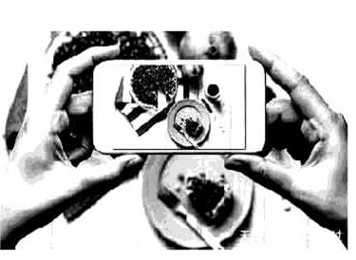
D
We can’t remember clearly since when we started to take our mobiles to a dinner table. This happens a lot, especially when we eat out. Once a dish comes, instead of lifting our chopsticks, we take out our mobiles and click. Later, we post the photos onto Weibo or Wechat，waiting to be “liked”. Then we check our mobiles from time to time during the meal, to see whether we get “liked” or not. We just cannot leave our mobiles for only a meal.
Does that sound familiar to you? Do you do that often? If not, how do you feel when others do that when having dinner with you?
A recent study suggests that what we are used to doing is not so good. Spending time taking photos of food makes the food less pleasant. To test this, some researchers did an experiment. Some people were asked to take photos before they could enjoy food. As a result, it showed that the more photos they took, ▲. So, why not stop taking photos and just enjoy the food in
front of you?
Besides the scientific result, there are also some other bad influences of taking photos of food before meals. After posting the photos onto the Internet, one will not be able to control himself and check his mobile many times. “Does everyone like my photos? I hope a lot of people like them!” It seems that your mobile secretly calls your name all the time, even when you are with real people.
So, next time you go out to have dinner with your family or friends, how about not taking photos of food? Let the food be delicious as it is and share your life with people around you. Trust me, it will be a wonderful time.
- From the passage, what happens a lot at the dinner table nowadays?
- People talk about their Weibo or WeChat.
- People learn from each other how to cook dishes.
- People like taking photos with friends or families.
- People take photos of food and post them before eating.
- Which of the following can be put in the ▲ in Paragraph 3?
- the less cheerful they became
- the less delicious the food seemed to them
- the more interested they were in the food
- the more “liked” they got on Weibo or Wechat
- What does the fourth paragraph talk about?
- The reasons for checking your mobiles.
- The ways of posting the photos onto the Internet.
- The tips (提示）of making others like your photos on the Weibo.
- Some other bad influences of taking photos of food before meals.
- Which of the following is the writer’s opinion?
- We take out our mobiles and click when a dish comes.
- We check our mobiles from time to time during the meal.
- Spending time taking photos of food makes the food less pleasant.
- Some people were asked to take photos before they could enjoy food.
- What can we learn from the passage?
- Take photos of food in order to have a wonderful life.
- Take photos of delicious food and share them with others.
- Remember to have dinner with our family and friends at home.
- Enjoy the life with people around us instead of taking photos of food.

五、口语交际（共5小题，计5分）
根据对话内容，从方框内选择恰当的句子填入对话相应的空白处，使对话完整，合乎情 景（有两个多余选项)。
(Carla and Victor are talking on the way home before the first day of the graduation exams.)
A: Good morning, Carla!
B: Good morning, Victor! We are leaving junior high school after the exams. I feel very sad.
A: Me too.
B: (66)
A: You’re welcome.
B: (67) They gave us too much.
A: Yes. It’s hard for us to say goodbye. Our school life was unforgettable.
B: You’re right. (68)
A: I hope to pass the exams to get into senior high school.
B: I trust you because you’re the most excellent in our class. But I’m going to an art school.
A: (69) I think you’ll be successful. By the way, our head teacher told me that
we will have a graduation party the next day after the exams. (70)
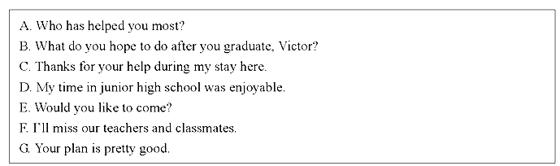
B: Sure. That’s great. It’s the moment we have a get-together.

第II卷（非选择题共40分）
- Who has helped you most?
- What do you hope to do after you graduate, Victor?
- Thanks for your help during my stay here.
- My time in junior high school was enjoyable.
- Would you like to come?
- I’ll miss our teachers and classmates.
- Your plan is pretty good.

六、单词拼写(共10小题，计10分）
(一）根据句意，用方框中所给单词的适当形式填空。
candle | prevent | wood | near | develop

- It is three years since we studied in this school.
- Doctors say too much pressure is not good for a child’s .
- —What you from joining us last night?
—The heavy rain.
- I never take chopsticks or plastic forks when I buy takeaway food.
- If the birthday person blows out all the in one go, the wish he has made will
come true.
(二）根据句意及汉语提示，填写句中所缺的单词。
- January and (二月)are the coldest months in Beijing.
- The Party members should be with themselves.
- A true friend (伸手）for your hand and touches your heart.
- In my hometown, there was a big old tree (在……对面）our school.
- I (相信）that a better environment can be created in Binzhou and we should work
together to make it come true.

七、动词应用（共10小题，计10分）
阅读下面短文，用括号内所给动词的适当形式填空，必要时可加助动词或情态动词。

One day, I took my daughter to the park. As soon as we
got there, my daughter (81) (run) to the swing (秋
千）and asked for a push. When I was helping my daughter，I noticed another girl trying to make her own swing (82)
(go) high by herself. Her old grandmother was
sitting on the chair nearby and smiling at us. Gradually, my daughter (83) (push) higher and higher by me.
Then I walked towards the little girl. I asked if I (84) (give) a big push to her. She
smiled and said “Yes”. For the next hour, I pushed the swings，and played with my daughter and the little girl. When we went home, I (85) (be) tired but very happy.
One day two years later, after a day’s work, I went to pick up my daughter before going home.
While I (86) (wait) outside the school gate, a little girl smiled sweetly at me and gave
me a big hug. As I watched her (87) (run) away, I realized that she was the girl whom
I gave a big push in the park.

So far, I (88) (not forget) her sweet smile and the warm hug that she gave me.
In fact, if we give love to others, love (89) (find) its way back to us. It may travel
from heart to heart or it may blossom (开花）in the heart. The love we share，the kindness we (90) (give), and the happiness we create will come back to us with a pleasant surprise.

八、 英汉互译（共5小题，计5分）
将下列英语句子译成汉语，汉语句子译成英语。
- The most valuable thing is time, rather than money.
- As you set out on your new journey, you shouldn’t forget where you came from.
- 我们应该更多地关注传统文化。（pay attention to)
- 如今一些父母对自己的孩子要求太严厉了。（be too hard on sb.)
- 不要怕犯错，我们可以从错误中学到东西。（learn from)

九、 书面表达（共1题，计15分）
下面是《小艾，爸爸特别特别想你》这本书的两幅插图。图中描绘了父亲陪伴小艾成 长的童年片段。父亲快到了，请结合自己的经历，以“爸爸，我想对你说……”开头，写一 篇英语短文，以表达对父亲的爱与感激之情。
要求：1.文中不得出现真实的姓名与校名；
- 语句通顺，结构合理，书写规范；
- 词数：80词左右。短文开头部分己给出，不计入总词数。
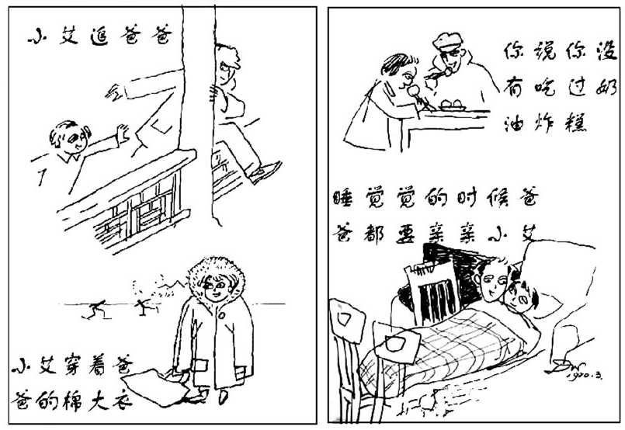
Dad, I want to say to you.

滨州市二〇一六年初中学生学业水平考试

英语试题（A)参考答案及评分说明

第I卷（选择题共80分）

第一至五题（80分）
(一） 答案：
1-5BBACA 6-10BCAAC 11—15ACBAC 16—20 BCBAC
21-25 CBAAA 26—30 BBCDC 31—35DADCB
36—40ACDBD
41-45BACCD 46—50 ACABD 51-55 CDABA
56—60DCABC 61-65DBDCD 66—70 CEBGE
(二） 评分说明：
1—45题，每小题1分；46—65题，每小题1.5分；66—70题，每小题1分；与答案不 符不得分。

第II卷（非选择题共40分）

六、 单词拼写(10分）
(一） 答案：
71. nearly 72. development 73. prevented 74. wooden 75. candles
76. February 77. strict 78. reaches 79. opposite 80. believe
(二） 评分说明：
- 本题共10分，每小题1分；
- 与答案不符，但只要符合题意也可得分。大小写错误每两处扣0.5分。

七、 动词应用（10分）
(一）答案：
- ran 82. go 83. was pushed 84. could give 85. was 86. was waiting 87. running 88. haven’t forgotten 89. will find 90. give
(二）评分说明：
- 本题共10分，每小题1分；
- 未用所给动词者不得分。与答案不符，但只要形式正确，符合题意也可得分。大小 写错误每两处扣0.5分。

八、 英汉互译（5分）
(一） 答案：
- 最珍贵的是时间，而不是金钱。
- 在新的旅行启程之际，不应忘了你来自何处。
- We should pay more attention to traditional culture.
- Some parents today are too hard on their children.
95 . Don’t be afraid of making mistakes; we can learn from them.
(二） 评分说明：
- 本题共5分，每小题1分；
- 虽然与答案表达方式不同，但与参考答案意思一致，无语言错误，也可酌情给分。 单词拼写错误每两处扣0.5分。

九、 书面表达（15分）
(一 )One possible version:
Dad, I want to say to you. In the past few years, you have done a lot for me. We spent much happy time together. With your great care, I grow healthily and happily. I remember when I was ill, you took me to the hospital immediately and took good care of me without a rest during the whole night. I remember you often took me somewhere interesting and bought the delicious food for me. I remember when I got good grades, you were always smiling…But now，you’re getting older and older. So I want to say: Please have a good rest and relax. Thank you for your love. I love you forever.
(二）评分说明：
要求考生用适当的时态、语态、句式和词语，完整准确地表达所提示的内容，书写工整。 本题共15分，.分四档评分：
- 短文通顺完整，表达清楚，语言基本无误，13 —15分；
- 短文较通顺完整，表达基本清楚，语言有少量错误，10 —12分；
- 能写明基本要点，短文不够通顺完整，语言有较多错误，但尚能达意，6—9分；
- 仅能写明部分要点，短文不完整，语言错误多，影响意思表达，0—5分。
注意：
- 内容要点可用不同的方式表达；
- 对紧扣主题适当发挥的应予以鼓励。

